OBSERVATION FOR JOB CARD MODULE
- Put “Manager Confirmation” just after completion of 1st phase.
- Add another field in 1st phase – Printing > Single side or Double side (Lot-pot), (Make a drop-down menu for this).
- Make 2 different tabs for SHEET SIZE and GSM in phase 2.
- PO attachment option while creating a Job Card. (in phase 1)
- Digital sample attachment option while creating a Job Card. (in phase 1 or phase 2).
- Make a notice box on PO If paper & board size is not available as per the required size. (APPROVAL WILL BE TAKEN ON THE HARD COPY OF PO).
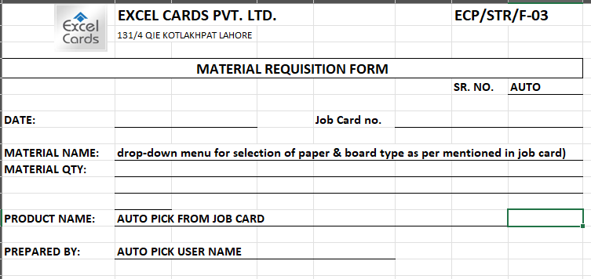
- Make an online “Material Requisition Form” for the demand and issuance of paper & board only. Production Dept. will make this form, and the Store Dept. will receive this form. Plz follow the specimen given below,

- Add the machine's name in production log. Names are as follows
Printing Dept.: Die cutting Dept. Folding & Gluing
Heidelberg 5 Color Bobst-1 FG-1
Heidelberg Solna 2 Color Bobst-2
Heidelberg CD-74 Kirma-1
KBA 102 Kirma-2

- Enable Q.C dept. at every step, and enable them to upload the pictures of the collected samples.
- Mention the job card number on the delivery note.
- Waste % working needs to be checked.
- Fix WhatsApp numbers of the users from the account data. (Jawad Sahb’s must be notified on the completion of job card.

